🦟 TinyML Mosquito Detector
A real time Aedes mosquito species classifier that runs entirely on a XIAO ESP32 S3 microcontroller using TinyML. The device listens for mosquito wingbeat sounds through the onboard PDM microphone and classifies the species with no internet connection required.

Overview
Mosquito borne diseases like dengue fever, Zika, and chikungunya affect millions of people every year, particularly in tropical regions. Early detection of disease carrying mosquito species is critical for public health response.
This project uses TinyML (Tiny Machine Learning) to classify two Aedes mosquito species based on their wingbeat frequency which is a unique acoustic fingerprint for each species. We also added other two species which are Anopheles and Culex.

Species | Wingbeat Frequency | Disease Risk
Aedes aegypti | ~ 450 to 600 Hz | Dengue, Zika, Chikungunya
Aedes albopictus  Anopheles Dirus  Culex CX Quin | ~ 550 to 700 Hz  ~ 200 to 700 Hz  ~ 366 to 463 Hz | Dengue, Chikungunya  Malaria  West Nile virus, Lymphatic filariasis, avian malaria.
The entire ML pipeline captures audio, DSP processing, and neural network inference and runs on a Xiao exp 32 s3 microcontroller in under 100 milliseconds.

Demo
DEMO video

Serial Monitor Output Example:
Predictions (DSP: 21 ms., Classification: 2 ms.):

aedes aegypti: 0.136719

aedes albopictus: 0.105469

noise: 0.648438

other species : 0.105469

>> Low confidence (0.65). No action.

Hardware Requirements
Component | Details
Microcontroller | Seeed XIAO ESP32-S3
Microphone | Onboard PDM microphone (MSM261D3526H1CPM)
Connection | USB C cable (data-capable)
Power | USB 5V

Software Requirements
- Arduino IDE 2.x
- ESP32 Board Package v2.0.16
- Edge Impulse Arduino Library
- I2S library (included with ESP32 board package)

How It Works
Microphone → DSP Processing → Neural Network → Species Classification → LED Output

Stage 1: Audio Capture
The onboard PDM microphone records audio at 8kHz sample rate. A FreeRTOS background task continuously fills a 2048 sample buffer with raw 16 bit audio data and applies 8x gain amplification.

Stage 2:DSP (Digital Signal Processing)
Edge Impulse's Mel Filterbank Energy (MFE) transforms the raw audio into a spectrogram which is a frequency vs time heatmap that highlights the mosquito's wingbeat frequency signature.

Stage 3: Neural Network Inference
The spectrogram is fed into a compact neural network trained on labeled wingbeat audio. It outputs confidence scores for each class: aegypti, albopictus, noises and other mosquito species.

Stage 4: Output
If confidence exceeds the 70% threshold, the result is reported via Serial Monitor and the built in LED blinks to indicate the detected species.

Dataset
Summary:
Class | Source | Samples
Aedes aegypti | Edge Impulse public dataset + field recordings from Kaggle. | 500
Aedes albopictus  Other species(Anopheles and Culex) | Edge Impulse public dataset + field recordings from Kaggle  Edge Impulse public dataset + field recordings from Kaggle | 500\  400 each
Noise / Background | Ambient environment recordings | 300
- Sample rate: 8000 Hz
- Sample length: ~1 to 2 seconds per clip
- Train / Test split: 80% / 20%
- Format: 16-bit mono WAV

Model Performance
Metric | Value
Overall Accuracy | 94.8%
Inference Time (DSP) | ~12 ms
Inference Time (Classification) | ~43 ms
Total Inference Time | < 100 ms
Model Size | < 50 KB (quantized)
See results for confusion matrix and accuracy charts.

Getting Started

1. Clone the Repository
git clone https://github.com/YOUR_USERNAME/tinyml-mosquito-detector.git
cd tinyml-mosquito-detector

2. Export the Edge Impulse Model
- Go to your Edge Impulse project dashboard
- Navigate to Deployment → Arduino Library
- Click Build and download the .zip file
- In Arduino IDE: Sketch → Include Library → Add .ZIP Library

3. Configure Arduino IDE
Set the following in Tools menu:
Setting | Value
Board | XIAO_ESP32S3
PSRAM | OPI PSRAM
Partition Scheme | Huge APP (3MB No OTA)
Upload Speed | 921600
USB CDC On Boot | Enabled

4. Upload the Code
- Open code.ino
- Hold BOOT button → press RESET → release BOOT (to enter download mode)
- Click Upload in Arduino IDE
- Open Serial Monitor at 115200 baud

LED Output Guide
LED Blink Pattern | Meaning
1 blink | Aedes aegypti detected
2 blinks | Aedes albopictus detected
No blink | Background noise / no mosquito/ Other species
Confidence threshold: 80% detects or/else below this are ignored to reduce false alarms.


Results

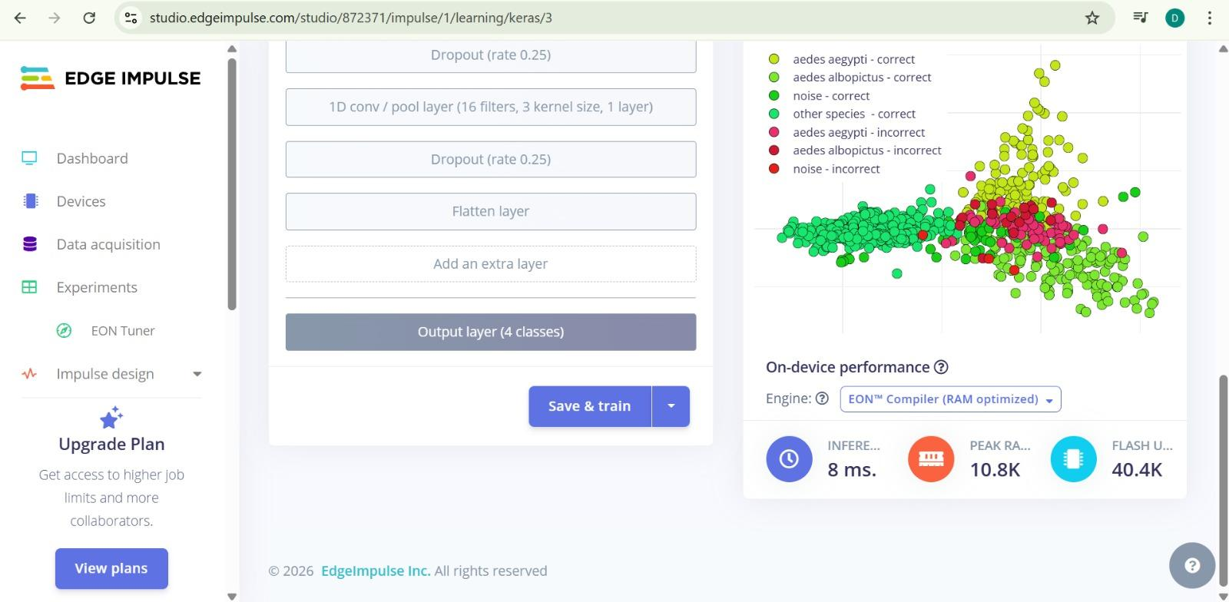

Key Findings:
- The model achieves 94.8% accuracy on the test set
- Aedes aegypti, Ae. albopictus and other species have overlapping wingbeat frequency ranges, making classification genuinely challenging
- Background noise is reliably rejected with the 80% confidence threshold
- Total inference time under 100ms enables real-time detection

Team & Learnings
What we learned building this project:
- How to collect, label, and balance an audio dataset for TinyML
- The role of DSP (Digital Signal Processing) in transforming raw audio into ML-ready features
- How FreeRTOS tasks enable parallel audio capture and inference on embedded hardware
- Debugging real hardware issues including ESP32-S3 boot mode upload errors
- The difference between cloud ML and edge ML, and why edge matters for field deployments.

Future Work
- Expand classification to include Anopheles and Culex species
- Add BLE/WiFi to log detections to a mobile app or cloud dashboard
- Improve robustness to outdoor background noise
- Test with live mosquito specimens under controlled conditions

License
This project is licensed under the MIT LICENSE.

Acknowledgements
- Edge Impulse — TinyML platform
- Seeed Studio — XIAO ESP32-S3 hardware
- Mosquito wingbeat dataset contributor (Kaggle)

